|  |
| --- |
| Functional Specification – Report |

|  |  |
| --- | --- |
| **1. Project:** | |
| **2. FS Name:** Invoice List Display | |
| **3. Reference: NA** | **4. Business Process:** Materials Management |
| **5. SAP Module:** MM | **6. Business Sub Process:** Invoice Receipt |
| **7. Author:** | **8. Reviewed By:** |
| **9. Status:** <Created/  Reviewed/Approved/Descoped> | **10. Status Date:** |
| **11. Priority:** <High/ Medium /Low> | **13. Process Owner :** |
| **12. Version No: 1.0** |  |

13. Document Revision History:

|  |  |  |  |  |
| --- | --- | --- | --- | --- |
| **Rev. No.** | **Change Request No.** | **Affected Pages** | Description of Change | **Date of Revision** |
|  |  |  |  |  |
|  |  |  |  |  |
|  |  |  |  |  |
|  |  |  |  |  |
|  |  |  |  |  |
|  |  |  |  |  |

14. Definition:

|  |  |
| --- | --- |
| **Migration Title:** | **Debit Note** |
| **Associated Business Event:** |  |
| **Application:** | Materials Management |
| **Comments:** |  |

15. Purpose:

This report is developed to get the information of actual Invoicing within a specified time bucket. The information on Invoicing (MIRO) can be analysed based on Vendor, Material and Purchase orders

The output display includes the information on Quantity and Amount.

The information of amount is available in Document currency..

16. Assumptions:

NA

17. Interface - Business Process Description:

Not Applicable

18. Conversion Type:

NA

19. Periodicity:

As & when required

20. Process Flow Diagram:

NA

21. Processing Logic:

Additional transactions code should be provided to enter the Invoice/Credit Note number.

1. Selection Screen:

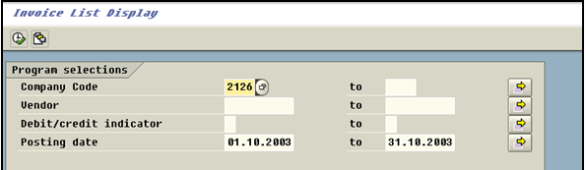

Initial Selection Screen should have following fields, which will be used derived the requisite information.

1. Company Code: The Company code field is mandatory.
2. Vendor: If the analysis is to be made for specific vendors the same can be achieved by entering the vendor code.
3. Debit/ Credit note Indicator: The selection can be made for display of credit note, Debit note or both.
4. Posting date: You can specify the date during which you want to analyze. By default it will select the previous Month.
5. Output:

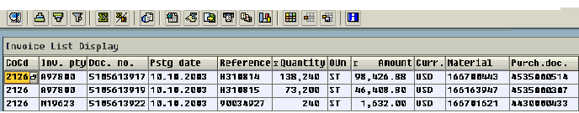

1. Company Code: (BKPF – BUKRS)
2. Vendor/ Invoicing Party (BSEG-LIFNR)
3. Doc. No (BKPF – BELNR)
4. Posting Date (BKPF-BUDAT)
5. Vendor Reference ( BSEG –XBLNR)
6. Quantity (BSEG- MENGE)
7. Base Un( BSEG-MEINS)
8. Amount (BSEG-DMBTR)
9. Currency (BKPF-WAERS)
10. Material(BSEG-MATNR)
11. Purch.Doc.(BKPF-EBELN)

22. Reporting:

AS specified in (Output Screen short) required in ALV/OOALV format.

23. Selection Screen:

As specified in the initial Selection Screen

24. File (Input/Output) Format: N/A

|  |  |  |  |  |  |  |  |
| --- | --- | --- | --- | --- | --- | --- | --- |
| Sr. No. | Field Name | Field Type | Field Length | Format | Mandatory | Validations/Comments | Field Mappings |
|  |  |  |  |  |  |  |  |

**NA**

**25. Field Mappings: N/A**

**Table Definitions**

|  |  |  |  |  |
| --- | --- | --- | --- | --- |
| **Sr. No.** | Field name | **Data Type** | Length | **Primary Key/Remarks** |
|  |  |  |  |  |

26. Participating Systems:

**From System:\***

NA

**To System:\***

NA

**31. Sign-Off**

|  |
| --- |
| Signed-Off By: |
| Sign-Off Date: |